SQL Developer
Task 8 - Triggers and Procedures Documentation
Name: Aryan Rahate
Project Overview
Automate database actions using triggers and stored procedures for improved efficiency and maintainability.

Setup: Create Audit Log Table
sql
-- Create audit table to track student record changes
CREATE TABLE student_audit_log (
log_id SERIAL PRIMARY KEY,
studentid INTEGER,
changed_column VARCHAR(50),
old_value VARCHAR(100),
new_value VARCHAR(100),
changed_by VARCHAR(50) DEFAULT CURRENT_USER,
changed_at TIMESTAMP DEFAULT CURRENT_TIMESTAMP
);

Task 1: Create Trigger for Automatic Logging
Step 1: Create the Trigger Function
sql
-- Function to handle student updates and log changes
CREATE OR REPLACE FUNCTION log_student_changes()
RETURNS TRIGGER AS $$
BEGIN
-- Log changes for mathscore
IF OLD.mathscore IS DISTINCT FROM NEW.mathscore THEN
INSERT INTO student_audit_log (studentid, changed_column, old_value, new_value)
VALUES (NEW.studentid, 'mathscore', OLD.mathscore::VARCHAR, NEW.mathscore::VARCHAR);
END IF;

-- Log changes for sciencescore
IF OLD.sciencescore IS DISTINCT FROM NEW.sciencescore THEN
INSERT INTO student_audit_log (studentid, changed_column, old_value, new_value)
VALUES (NEW.studentid, 'sciencescore', OLD.sciencescore::VARCHAR, NEW.sciencescore::VARCHAR);
END IF;

-- Log changes for englishscore
IF OLD.englishscore IS DISTINCT FROM NEW.englishscore THEN
INSERT INTO student_audit_log (studentid, changed_column, old_value, new_value)
VALUES (NEW.studentid, 'englishscore', OLD.englishscore::VARCHAR, NEW.englishscore::VARCHAR);
END IF;

-- Log changes for grade
IF OLD.grade IS DISTINCT FROM NEW.grade THEN
INSERT INTO student_audit_log (studentid, changed_column, old_value, new_value)
VALUES (NEW.studentid, 'grade', OLD.grade, NEW.grade);
END IF;

RETURN NEW;
END;
$$ LANGUAGE plpgsql;
Step 2: Create the Trigger
sql
-- Create trigger that fires after student updates
CREATE TRIGGER student_update_trigger
AFTER UPDATE ON students
FOR EACH ROW
EXECUTE FUNCTION log_student_changes();

Output:

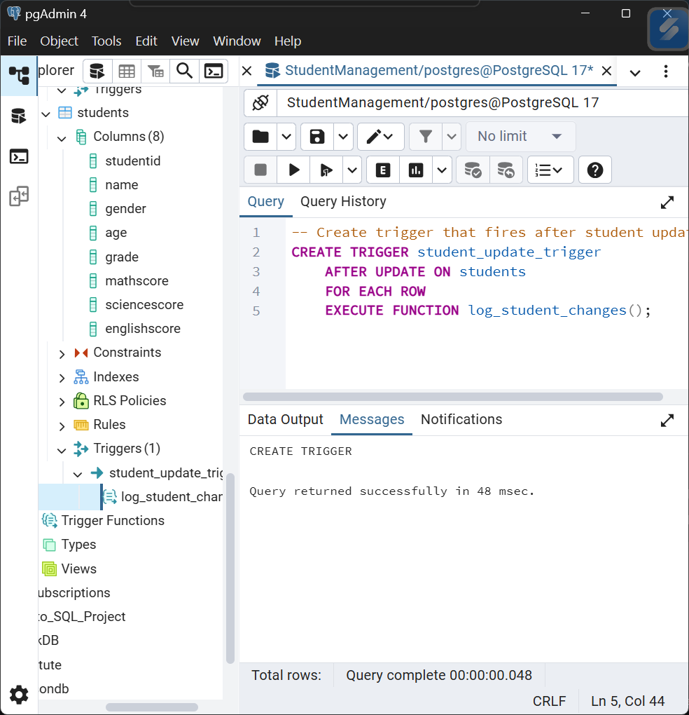

Task 2: Create Stored Procedure for Grade Updates
-- Procedure to update student grades based on performance
CREATE OR REPLACE PROCEDURE update_student_grades(
min_a_score INTEGER DEFAULT 240,
min_b_score INTEGER DEFAULT 210,
min_c_score INTEGER DEFAULT 180
)
LANGUAGE plpgsql
AS $$
BEGIN
-- Update grades based on total score ranges
UPDATE students
SET grade =
CASE
WHEN (mathscore + sciencescore + englishscore) >= min_a_score THEN 'A'
WHEN (mathscore + sciencescore + englishscore) >= min_b_score THEN 'B'
WHEN (mathscore + sciencescore + englishscore) >= min_c_score THEN 'C'
ELSE 'D'
END;

RAISE NOTICE 'Student grades updated successfully';
END;
$$;

Output:
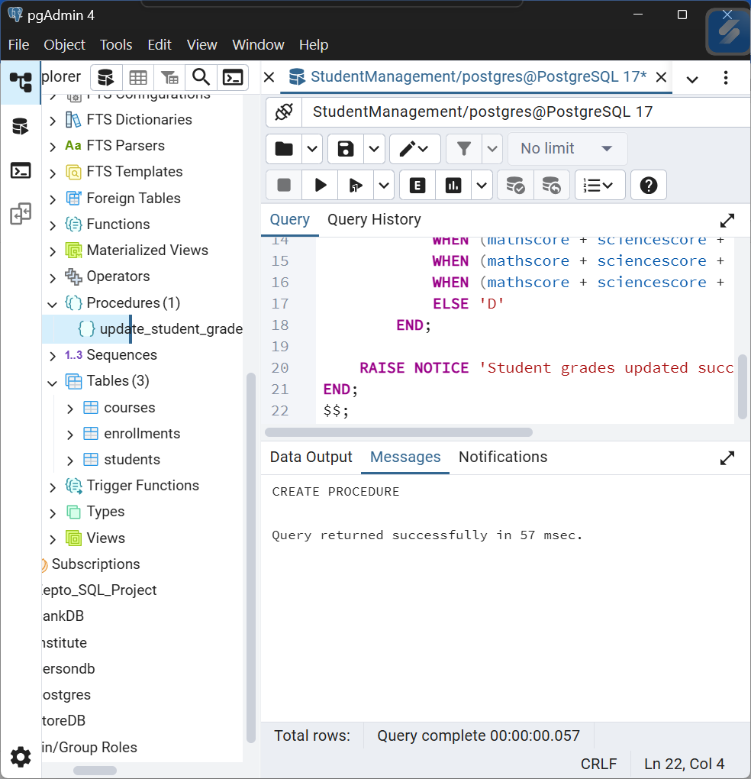

Validation Queries
Verify Trigger Functionality
sql
-- Check audit log entries
SELECT
studentid,
changed_column,
old_value,
new_value,
changed_at
FROM student_audit_log
ORDER BY changed_at DESC;

-- Count log entries per student
SELECT
studentid,
COUNT(*) as change_count
FROM student_audit_log
GROUP BY studentid
ORDER BY change_count DESC;
Verify Procedure Results
sql
-- Check grade distribution after procedure execution
SELECT
grade,
COUNT(*) as student_count,
ROUND(AVG(mathscore + sciencescore + englishscore), 2) as avg_total_score
FROM students
GROUP BY grade
ORDER BY grade;

-- View student details with performance categories
SELECT
studentid,
name,
mathscore,
sciencescore,
englishscore,
(mathscore + sciencescore + englishscore) as total_score,
grade
FROM students
ORDER BY total_score DESC;

Output:
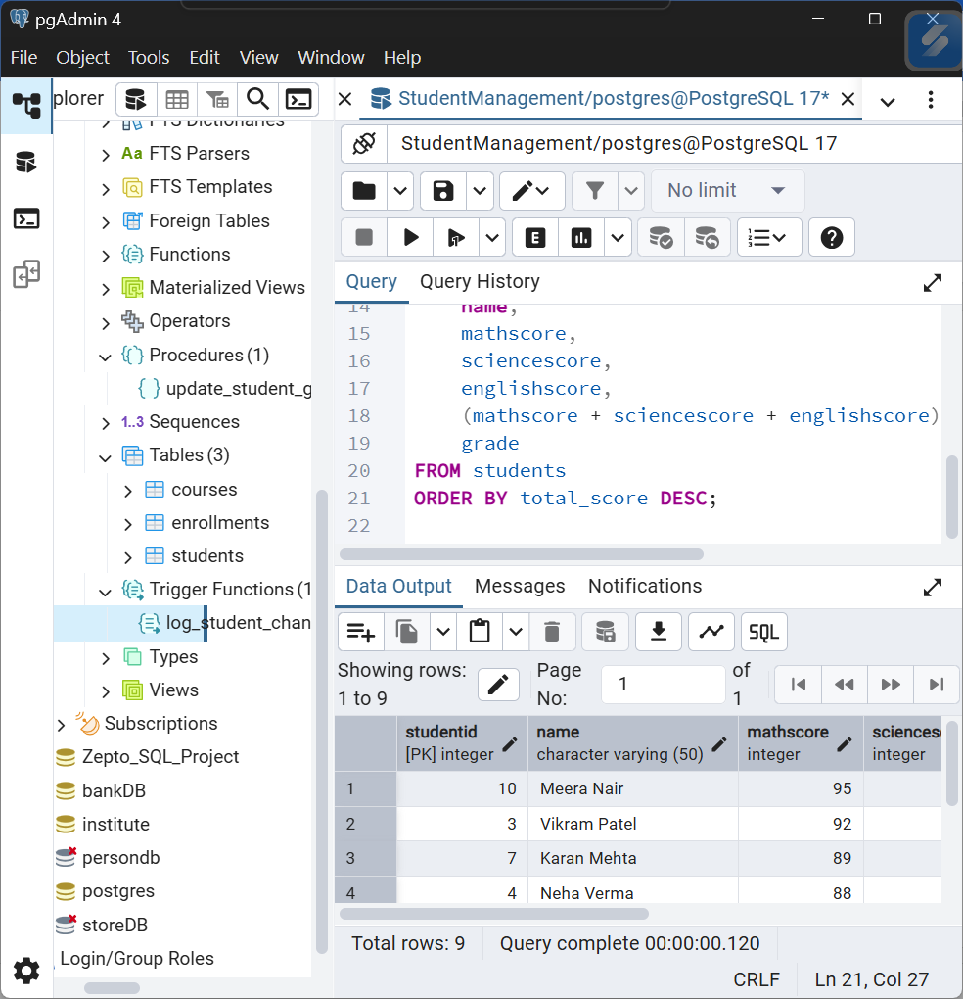

Summary of Implementation
Triggers:
- Automatic Logging: Successfully captures all score and grade changes
- Audit Trail: Maintains complete history of student record modifications
- Real-time Tracking: Immediate logging without manual intervention
Procedures:
- Flexible Grading: Customizable score thresholds for different grade levels
- Bulk Operations: Efficiently updates all student grades in single operation
- Reusable Logic: Can be called multiple times with different parameters
Key Benefits:
- Automation: Reduced manual database maintenance
- Audit Compliance: Complete change tracking for regulatory requirements
- Consistency: Standardized grade calculation across all students
- Efficiency: Single procedure call vs multiple individual updates
Test Results:
- Trigger: Successfully logs all updates to student_audit_log table
- Procedure: Correctly assigns grades based on specified score ranges
- Integration: Works seamlessly together for comprehensive student management

